***Section* 3.3 – Integral Test**

**Nondecreasing Partial Sums**

Suppose that  is an infinite series with  for all *n*. Then each partial sum is greater than or equal to its predecessor because :



***Corollary***

A series  of nonnegative terms converges if and only if its partial sums are bounded from above.

***Example***

The series 

***Solution***



The sum of the first 2 terms is .

The sum of the next 2 terms is 

The sum of the next 4 terms is 

  

The sum of  terms ending with  is 

The sequence of partial sums is not bounded from above: If , the partial sum .

The harmonic series diverges.

**The Integral Test**

***Theorem***

Let  be a sequence of positive terms. Suppose that , where  is a continuous, positive, decreasing function of *x* for all  (*N* a positive integer). Then the series  and the integral  both converge or both diverge.

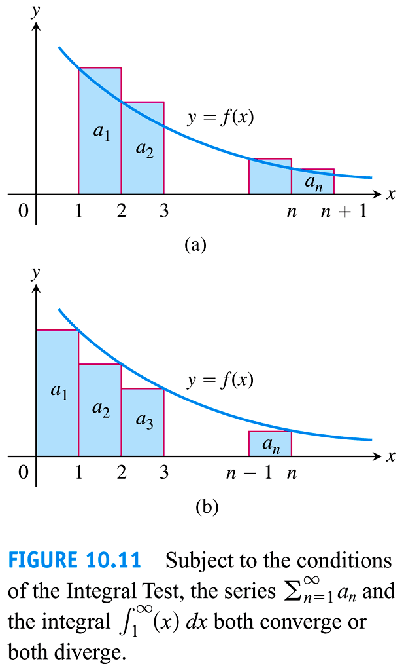 

***Example***

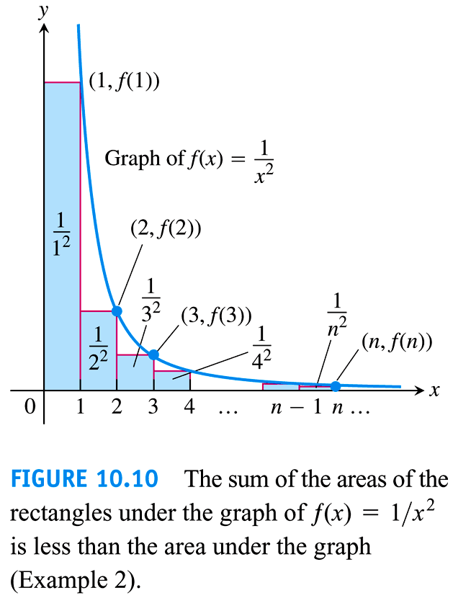Does the following series converge? 

***Solution***















Thus, the partial sums are bounded from above by 2 and the series converges.





***p*-*series***

***Example***

Show that the ***p***-*series* 

(*p* a real constant) converges if *p* > 1, and diverges if *p* ≤ 1.

***Solution***





 ***p* > 1**





The series ***converges*** when *p* > 1.

if *p* ≤ 1





The series ***diverges***.

***Example***

Does the following series converge 

***Solution***









The series ***converges***, but we do not know the value of its sum

**Bounds for the Remainder in the Integral Test**

Suppose  is a sequence of positive terms with , where  is a continuous positive decreasing function of *x* for all *x* ≥ *n*, and that  converges to *S*. Then the remainder  satisfies the inequalities



***Example***

Estimate the sum of the series  with *n* = 10

***Solution***















If we approximate the sum *S* by the midpoint of this interval, then



The error in this approximation is less than half the length of the interval, so the error is less than 0.005.

***Exercises Section* 3.3 – Integral Test**

(**1 − 22**) Use the ***Integral Test*** to determine if the series converge or diverge.

|  |  |  |
| --- | --- | --- |
|  |  |  |

(**23 − 28**) Use the ***p-series Test*** to determine if the series converge or diverge.

|  |  |  |
| --- | --- | --- |
|  |  |  |

(**29 − 54**) Determine if the series converge or diverge

|  |  |  |
| --- | --- | --- |
|  |  |  |

1. Consider the series , where *p* is a real number.
2. Use the Integral Test to determine the values of *p* for which this series converges.
3. Does this series converge faster for  or ? Explain.
4. Consider the series , where *p* is a real number.
5. For what values of *p* does this series converge?
6. Which he following series converge faster? Explain.

 or 

1. Consider a wedding cake of infinite height, each layer of which is a right circular cylinder of height 1. The bottom layer of the cake has a radius of 1, the second layer has a radius of , the third layer has a radius of , and the *nth* layer has a radius of .

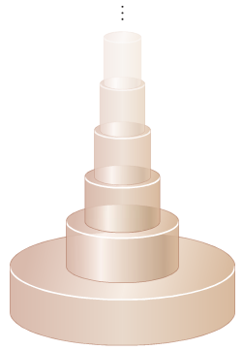

1. To determine how much frosting is needed to cover the cake, find the area of the lateral (vertical sides of the wedding cake. What is the area of the horizontal surfaces of the cake?
2. Determine the volume of the cake.
3. Comment on your answer to parts (*a*) and (*b*)
4. The Riemann zeta function is the subject of extensive research and is associated with several renowned unsolved problems. Is its defined by , when *x* is a real number, the zeta function becomes a *p-*series. For even positive integers *ρ*, the value of  is known exactly. For example,



1. Use the estimation techniques to approximate  and  (whose values are not known exactly) with a remainder less than .
2. Determine the sum of the reciprocals of the squares of the odd positive integers by rearranging the terms of the series  without changing the value of the series.
3. Consider a set of identical dominoes that are 2 *inches* long. The dominoes are stacked on top of each other with their long edges aligned so that each domino overhangs the one beneath is as far as possible

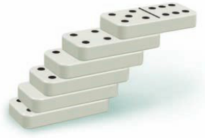

1. If there are *n* dominoes in the stack, what is the greatest distance that the top domino can be made to overhang the bottom domino? (*Hint*: Put the *nth* domino beneath the previous  dominoes.)
2. If we allow for infinitely many dominoes in the stack, what is the greatest distance that the top domino can be made to overhang the bottom domino?
3. A theorem states that the sequence of prime numbers  satisfies .

Show that  diverges, which implies that the series 

(A prime number is a positive integer number that is divisible only by 1 and itself).